Conclusions

Overall Disease Spread
Total reported cases ≈ 229.8 million
Total deaths ≈ 51,593
There is a huge gap between cases and deaths, indicating many diseases are widespread but not always fatal.

Most Prevalent Diseases (Cases)
Acute Respiratory Infection dominates with ~145M cases
Followed by:
Acute Diarrhoeal Diseases with ~45M
Typhoid with ~7.9M
Neonatal Tetanus with ~4.4M
Cholera with ~4M

Conclusion:
Respiratory and water-borne diseases are the primary public health burden in India.

Most Fatal Diseases (Deaths)
Pneumonia (All Causes) → Highest deaths
Acute Respiratory Infection → 2nd highest
Acute Diarrhoeal Diseases → 3rd

Insight:
Some diseases (like pneumonia) may not have the highest cases but have high mortality rates, making them critical for policy focus.

Gender-Based Insights
Cases: Males slightly higher than females
Deaths: Males significantly higher (~60%)

Conclusion:
Men are either:
- More exposed to risk factors, OR
- Less likely to seek early treatment
This reflects a behavioral + access-to-care gap.

Year-wise Trend
Cases increased from 2017 → 2019, then dropped in 2020
Deaths, however, consistently increased, peaking in 2020

Interpretation:
The drop in cases in 2020 may be due to:
- Underreporting (COVID disruption)
- Healthcare system overload
- Rising deaths suggest worsening healthcare outcomes or delayed treatment

Variability in Data
Very high standard deviation in cases → indicates huge disparity across states/diseases
Some diseases have extremely low cases but non-zero deaths, signaling high severity

Strategic Insights:
Public Health Prioity Areas include Respiratory infections and Water-borne diseases. These cases can be prevented by preventing disease, promoting well-being, and strengthening health systems

Policy Focus Needed in areas like Preventive healthcare (sanitation, vaccination), Rural healthcare infrastructure where Government control is necessary.

Behavioral Insight:
Gender gap suggests need for targeted awareness campaigns.

Final Conclusion
India’s disease landscape is dominated by high-volume infectious diseases, but mortality is concentrated in specific severe conditions. There is a mismatch between disease prevalence and fatality, indicating the need for targeted healthcare interventions rather than uniform resource allocation.

Disease Type vs Cases
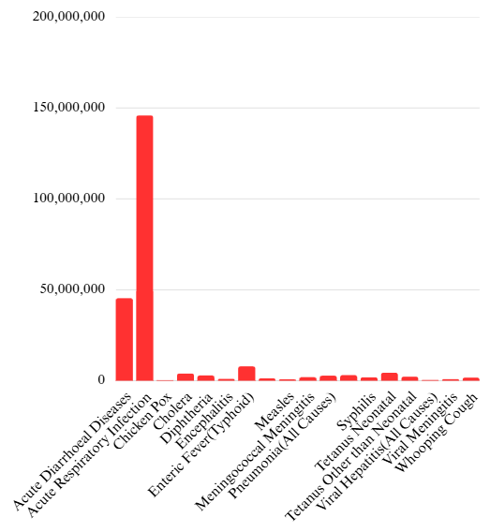

Disease Type vs Death
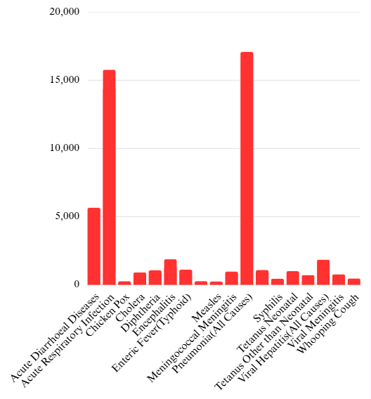

Cases vs Year
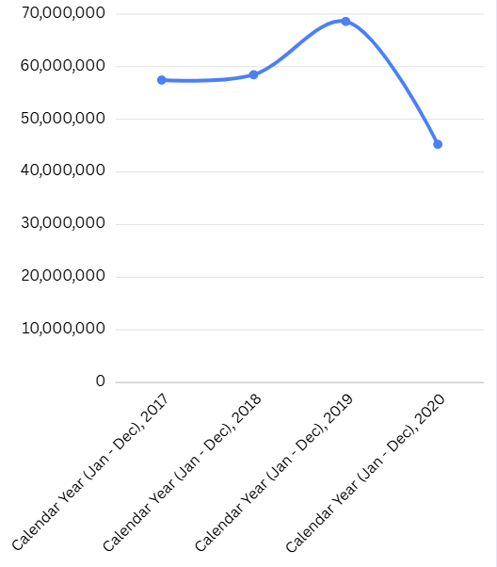

Deaths vs Year
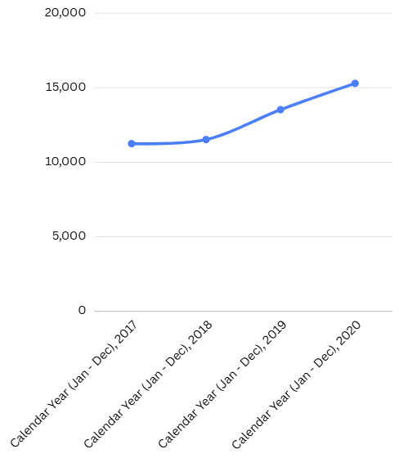

Gender vs Cases
